|  |  |  |  |  |
| --- | --- | --- | --- | --- |
| **WEEK** | **VALUE PROMISE** | **MEMORY VERSE** | **CHARACTER TRAITS** | **WORK HABIT** |
| **TWO** | “ I believe in only one God as my God ”. | Matthew 25:35 | 1. Be caring  2. Be responsible  3. Be hospitable  4. Be receptive  5. Have individual responsibility | Do not settle for anything less than excellence |

Matthew 25:35 “For I was hungry and you gave me food I was thirsty and you gave me a drink, I was a stranger, and you invited me in”.

Work habit

Name: \_\_\_\_\_\_\_\_\_\_\_\_\_\_\_\_\_\_\_\_\_\_\_\_\_\_\_\_\_\_\_\_\_\_\_\_\_\_\_\_\_

Date: \_\_\_\_\_\_\_\_\_\_\_\_\_\_\_\_\_\_\_\_\_\_\_\_\_\_\_\_\_\_\_\_\_\_\_\_\_\_\_\_\_\_

School: \_\_\_\_\_\_\_\_\_\_\_\_\_\_\_\_\_\_\_\_\_\_\_\_\_\_\_\_\_\_\_\_\_\_\_\_\_\_\_\_\_

Spellings Corrections

1. 1.

2. 2.

3. 3.

4. 4.

5. 5.

**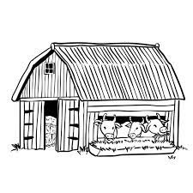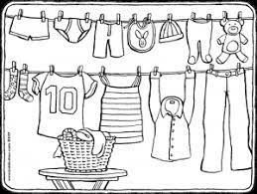Use the pictures to complete sentences.**

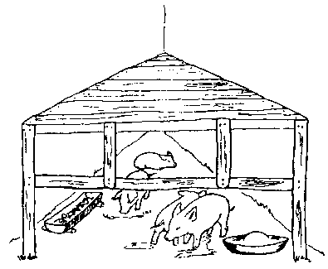



1. The khangas

2. The cows

3. The cat

4. The pig

5. The boy

was under the table.

was in the pigsty.

were on the clothes line.

was reading.

were in the cowshed.

**Work to do.**

**Give their names.**

1. A person who treats sick people is called a

2. A person who drives cars is called a

3. A person who teaches children is called a

4. A person who makes clothes is called a

5. A person who catches fish is called a

teacher doctor driver fisher man tailor

Corrections

***Score strip***

Name: \_\_\_\_\_\_\_\_\_\_\_\_\_\_\_\_\_\_\_\_\_\_\_\_\_\_\_\_\_\_\_\_\_\_\_\_\_\_\_\_\_

Date: \_\_\_\_\_\_\_\_\_\_\_\_\_\_\_\_\_\_\_\_\_\_\_\_\_\_\_\_\_\_\_\_\_\_\_\_\_\_\_\_\_\_

School: \_\_\_\_\_\_\_\_\_\_\_\_\_\_\_\_\_\_\_\_\_\_\_\_\_\_\_\_\_\_\_\_\_\_\_\_\_\_\_\_\_

Spellings Corrections

1. 1.

2. 2.

3. 3.

4. 4.

5. 5.

**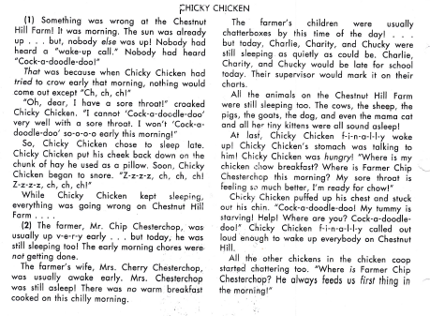**

**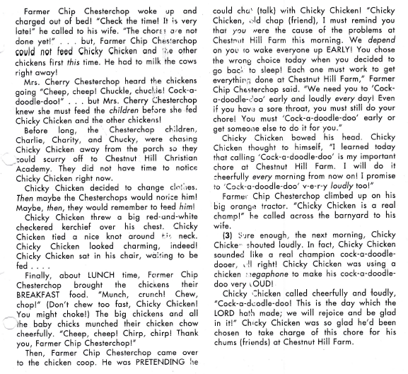**

**SOUND “CH”**

**Join and read.**

**in**  ben-ch-

ch art lun-ch-

op ch-ur-ch-

**Read aloud.**

church pinch

ranch branch

**Read and form sentences with these words.**

chart

chick

lunch

**Puzzle**

Use the words in the box to finish

each sentence. Then write the words in the puzzle.

**Across**

1

4

3

2

5

**Her hat is red**  .

**We ate a ham sandwich for** .

**Down**

**Did, my dog**

**the cat?**

**will we**

**take the quiz?**

**Dad will**

**the logs.**

Corrections

***Score strip***

Name: \_\_\_\_\_\_\_\_\_\_\_\_\_\_\_\_\_\_\_\_\_\_\_\_\_\_\_\_\_\_\_\_\_\_\_\_\_\_\_\_\_

Date: \_\_\_\_\_\_\_\_\_\_\_\_\_\_\_\_\_\_\_\_\_\_\_\_\_\_\_\_\_\_\_\_\_\_\_\_\_\_\_\_\_\_

School: \_\_\_\_\_\_\_\_\_\_\_\_\_\_\_\_\_\_\_\_\_\_\_\_\_\_\_\_\_\_\_\_\_\_\_\_\_\_\_\_\_

Spellings Corrections

1. 1.

2. 2.

3. 3.

4. 4.

5. 5.

**Read aloud.**

**tall**

**small**

**Ball**

**alright**

**fall**

**Reading compression**

Read the text and answer the questions.

**Money Rain**

Jen stared mindlessly out of her window.

He parents had grounded her and she couldn’t begin to describe how bored she was. Jen sighed as she wanted the rain fell and heard the thunder in the distances. The New had forecast the worst storm in the city’s history, and it was absolutely bucketing down. As Jen’s mind continued to wander, she noticed something strange about the rain it wasn’t ran that was falling, it was money!

Jen woke from her daze and fixed her glasses. “What on earth”, she muttered to herself. “That’s money”! She exclaimed. Jen sprinted outside as fast as she could and begin collecting the notes that fell from the sky.

**Question**

1. What does mindlessly means?

2. Why was Jen stuck in her room?

3. What had the news forecast?

4. What does bucketing down mean?

5. How did she feel when she saw money coming from sky?

Circle the word that names each picture. Then write the word on the line. Write a sentence using one of the words you wrote.

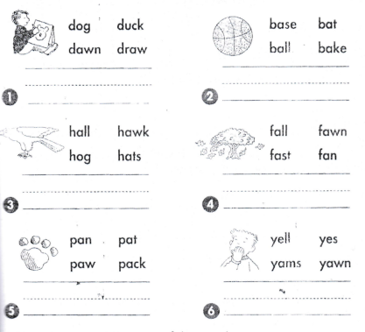

Image result for sister images black and white

Corrections

***Score strip***

**What Am I?**

ball

claw

small

saw

mall

Use the words in the box to answer each

riddle. Write the words in the puzzle.

**ACROSS**

**I’m not big. What am I?**

**I’m in a game with bases. What am I?**

**DOWN**

5

2

3

1

4

**I’m on the foot of a hawk. What am I?**

**I’m a place to shop. What am I?**

**I can cut logs. What am I?**

***Score strip***

****

Checkup 1

Supervisor’s initial \_\_\_\_\_\_\_\_\_\_\_\_

Score \_\_\_\_\_\_\_\_\_\_\_\_\_\_\_

Supervisor’s comment \_\_\_\_\_\_\_\_\_\_\_\_\_\_\_\_\_\_\_\_\_\_\_\_

**PROJECT WORK**

**Requirements**

Newspapers

Scrap book

Request for newspapers from your teacher. Using newspapers, search for four words of sound “ch” and cut them out. Get your scrap book and paste them in.

Then, construct three sentences about each of the words you found.

|  |  |  |  |  |
| --- | --- | --- | --- | --- |
| **WEEK** | **VALUE PROMISE** | **MEMORY VERSE** | **CHARACTER TRAITS** | **WORK HABIT** |
| **THREE** | “I will always be true and do the right things”. | 1st Timothy 4:12 | 1. Be of great integrity & dignity  2. Be truthful  3. Be genuine  4. Endurance & honesty  5. Be bold | Be gentle to all and stern to all |

1st Timothy 4:12 “Do not let anyone look down on you because you are young, but be an example for the believers in your speech your conduct, your love, faith and purity”.

Work habit

Name: \_\_\_\_\_\_\_\_\_\_\_\_\_\_\_\_\_\_\_\_\_\_\_\_\_\_\_\_\_\_\_\_\_\_\_\_\_\_\_\_\_

Date: \_\_\_\_\_\_\_\_\_\_\_\_\_\_\_\_\_\_\_\_\_\_\_\_\_\_\_\_\_\_\_\_\_\_\_\_\_\_\_\_\_\_

School: \_\_\_\_\_\_\_\_\_\_\_\_\_\_\_\_\_\_\_\_\_\_\_\_\_\_\_\_\_\_\_\_\_\_\_\_\_\_\_\_\_

Spellings Corrections

1. 1.

2. 2.

3. 3.

4. 4.

5. 5.

**THE RED-HEADED WOOD PECKER**

Phyllis sat in her own room. The window was open and into the room darted a bird. In a moment he flow to the ledge above her door. With his strong little bill lie began to rap ,rap at the wood.”You act like a wood pecker, but you do not look like one ,”said Phyllis. ”you do not know all about wood peckers,”

Said the bird. “I belong to the family of red headed wood pecker, “You?” cried Phyllis.But where is your red cap? “I am a wood pecker surely.

But l am quite young yet My mother said,”What a little longer, when you are quite grown your cap will be as red as my owen. “Well”, “said phillis” I am very glad you came to see me.

“Do you stay have in , We often stay all winter , then? “phillis asked “Oh yes, We often stay all winter, must you go? Asked phillis. Here a strawberry for you! Thanks, “said the bird, pecking away at the fruit.

QUESTIONS

1. What did the bird do in to the phyllis’ room?

2. What did phllis say to the bird?

3. What did wood pecker reply?

4. Why did Phyllis happy?

5. What did Phyllis give to the wood pecker?

6. Do you like birds? Tell the name of your favorite bird?

**Follow the Directions**

**Look at each row of pictures. Which person is following the directions? Circle that person.**

|  |  |
| --- | --- |
| **in rows.png**  **Plant seeds in rows.** | in rows no.png  **Plant seeds in rows.** |

|  |  |
| --- | --- |
| **water plants nap.png**  **Water the plants** | water plants.png  **Water the plants** |
| **weed.png**  **Weed every day.** | weed day.png  **Weed every day.** |
| **cut flower.png**  **Put cut flowers in water** | cut flower h.png  **Put cut flowers in water** |

Name: \_\_\_\_\_\_\_\_\_\_\_\_\_\_\_\_\_\_\_\_\_\_\_\_\_\_\_\_\_\_\_\_\_\_\_\_\_\_\_\_\_

Date: \_\_\_\_\_\_\_\_\_\_\_\_\_\_\_\_\_\_\_\_\_\_\_\_\_\_\_\_\_\_\_\_\_\_\_\_\_\_\_\_\_\_

Spellings Corrections

1. 1.

2. 2.

3. 3.

4. 4.

5. 5.

In a good hand writing, write about your school.

***Score strip***

Name: \_\_\_\_\_\_\_\_\_\_\_\_\_\_\_\_\_\_\_\_\_\_\_\_\_\_\_\_\_\_\_\_\_\_\_\_\_\_\_\_\_

Date: \_\_\_\_\_\_\_\_\_\_\_\_\_\_\_\_\_\_\_\_\_\_\_\_\_\_\_\_\_\_\_\_\_\_\_\_\_\_\_\_\_\_

Spellings Corrections

1. 1.

2. 2.

3. 3.

4. 4.

5. 5.

**Reading Practice**

Practice blending these sounds into words.

i

kind

wild

wind

child

blind

behind

i-e

line

kite

ride

pine

life

quite

smile

igh

high

light

tight

night

might

right

flight

ie

die

tie

lie

pie

Y

try spy July

cry why reply

sky shy type

**Match their picture with their names.**

wipe kite five tie time

pipe ride fire line

|  |  |
| --- | --- |
| C:\Users\DELL\Desktop\pins 3\group 2\0282c44da07a57ea713637ed1876199f.jpg  t | father-clip-art-black-and-white-necktie_lineart  t |
| Description: MC900112302[1]  f | C:\Users\LG COMPUTERS\Desktop\New folder (3)\Reading workbook\wiping.png  w |
| C:\Users\DELL\Desktop\pins 3\group 2\Pins\7ece173f1af2a6c03d517964dd038aea.jpg  k | C:\Users\LG COMPUTERS\Desktop\New folder (3)\Reading workbook\riding 2.jpg  r |
| C:\Users\LG COMPUTERS\Desktop\New folder (3)\Reading workbook\post box.jpg  p | li |
| C:\Users\LG COMPUTERS\Desktop\New folder (3)\Reading workbook\pipe 2.png  p\_\_p | f |

**Read these sentences.**

1. I can make a kite.

2. He wants to buy a pie.

3. What is the time?

4. He has mice in his house.

5. My father is a wise man.

6. He has ten ties.

**Circle Your Choice**

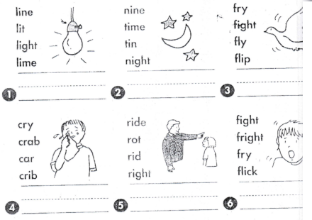SO02022_Circle the word that names each picture. Then write the word on the line.

Write a sentence using each word given.

**Why**

**Try**

Corrections

***Score strip***



Checkup 2

Supervisor’s initial \_\_\_\_\_\_\_\_\_\_\_\_

Score \_\_\_\_\_\_\_\_\_\_\_\_\_\_\_

Supervisor’s comment \_\_\_\_\_\_\_\_\_\_\_\_\_\_\_\_\_\_\_\_\_\_\_\_

**PROJECT WORK**

At home, write five activities that are taking place. Write them down on a piece of paper and when you arrive at school the following day, give the work to the teacher and read the words aloud.

|  |  |  |  |  |
| --- | --- | --- | --- | --- |
| **WEEK** | **VALUE PROMISE** | **MEMORY VERSE** | **CHARACTER TRAITS** | **WORK HABIT** |
| **FOUR** | “I choose to do what glorifies the Lord”. | Mathew 7:12 | 1. Be tender & considerate  2. Be loving  3. Be just & kind  4. Be truthful & peaceful  5. Avoid favoritism and being judgmental | Be kind whenever possible. It is always possible |

Mathew 7:12 “Do for others what you would wish them to do for you”.

Work habit

Name: \_\_\_\_\_\_\_\_\_\_\_\_\_\_\_\_\_\_\_\_\_\_\_\_\_\_\_\_\_\_\_\_\_\_\_\_\_\_\_\_\_

Date: \_\_\_\_\_\_\_\_\_\_\_\_\_\_\_\_\_\_\_\_\_\_\_\_\_\_\_\_\_\_\_\_\_\_\_\_\_\_\_\_\_\_

School: \_\_\_\_\_\_\_\_\_\_\_\_\_\_\_\_\_\_\_\_\_\_\_\_\_\_\_\_\_\_\_\_\_\_\_\_\_\_\_\_\_

Spellings Corrections

1. 1.

2. 2.

3. 3.

4. 4.

5. 5.

**Read aloud.**

**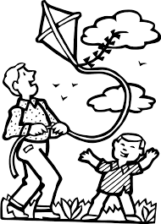THE KITE**

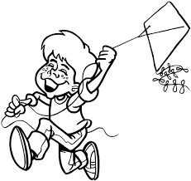

Pip and Tess went to the

Park to fly a kite. The

wind blew the kite high in

in the sky

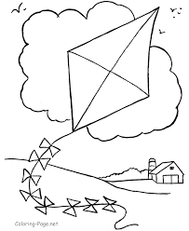

The wind swept them

over five pine trees. “I like

gliding’, smiled Pip.

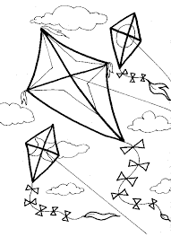

The wind was strong.

They tried to hold on

to the kite with all their might.

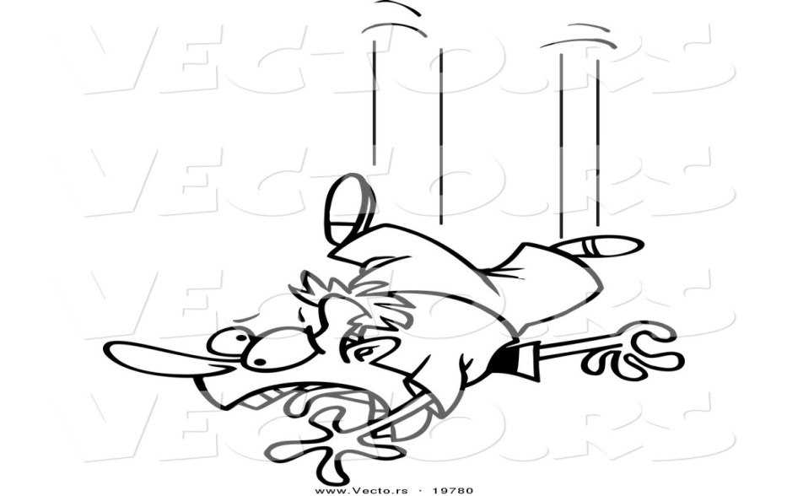

But Tess did not

smile. Then the string

Snapped. “HELP!”

they cried as they

dived down.

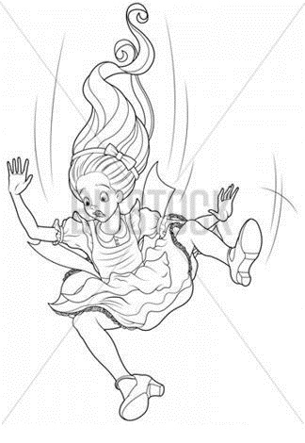

Tess tried to grab a pine tree

But they kept diving down

“I don’t like this, “she cried.

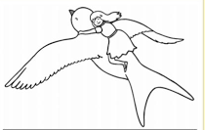

Just then, Flip came flying by.

“Would you like a ride?” he asked.

You saved our lives! said Pip.

**Team activity**

**Questions for discussion:**

Why do you think Pip and Tess got swept up into the sky?

Why does it say,’ But Tess did not smile?

How do you think the ants felt when they got on to flips back?

Reading theatre

|  |  |  |  |
| --- | --- | --- | --- |
| Value | Fair | Good | Excellent |
| Intonation |  |  |  |
| Confidence |  |  |  |
| Expression |  |  |  |
| Punctuation |  |  |  |

***Score strip***

Name: \_\_\_\_\_\_\_\_\_\_\_\_\_\_\_\_\_\_\_\_\_\_\_\_\_\_\_\_\_\_\_\_\_\_\_\_\_\_\_\_\_

Date: \_\_\_\_\_\_\_\_\_\_\_\_\_\_\_\_\_\_\_\_\_\_\_\_\_\_\_\_\_\_\_\_\_\_\_\_\_\_\_\_\_\_

Spellings Corrections

1. 1.

2. 2.

3. 3.

4. 4.

5. 5.

It is illegal and dangerous to follow another vehicle too closely. It is called tailgating.

Often car accidents occur when drivers following too closely behind another car. As a rule, drivers must maintain a safe distance from the vehicle a head in case they need to stop. It is recommended that drivers allow at least two seconds between their car and the one in front of them. It means that at 60kph, there should be 33 meters between the two cars; at 100kph, there should be 55 meters. When the weather is bad or visibility is poor. Stopping the vehicles safely requires even more space.

Question

1. Is following a vehicle closely legal?

2. What does tailgating mean?

3. What will you tell your parents if they drive tailgating

4. What is the safe distance according to the rules?

5. Why does bad weather require more time?

**SOUND CK**

**How many words can you make?**

|  |  |  |  |
| --- | --- | --- | --- |
| **de** | **ki** | **ne** | **lu** |
| **so** | **ba** | **ck** | **mu** |
| **ra** | **k** | **clo** | **ha** |

**Join and read.**

ra

du t to

ki

li

clo lo

pe

\_

**Let’s read out loud.**

1. His back is bent.

2. Go and get a duck.

3. I will pick an egg.

4. Pack his cups well.

5. I am very sick.

**Form sentences from the words below.**

Neck

Kick

Back

Corrections

***Score strip***

Name: \_\_\_\_\_\_\_\_\_\_\_\_\_\_\_\_\_\_\_\_\_\_\_\_\_\_\_\_\_\_\_\_\_\_\_\_\_\_\_\_\_

Date: \_\_\_\_\_\_\_\_\_\_\_\_\_\_\_\_\_\_\_\_\_\_\_\_\_\_\_\_\_\_\_\_\_\_\_\_\_\_\_\_\_\_

Spellings Corrections

1. 1.

2. 2.

3. 3.

4. 4.

5. 5.

Dandelion series unit

Reading theatre

|  |  |  |  |
| --- | --- | --- | --- |
| Value | Fair | Good | Excellent |
| Intonation |  |  |  |
| Confidence |  |  |  |
| Expression |  |  |  |
| Punctuation |  |  |  |

***Score strip***

Name: \_\_\_\_\_\_\_\_\_\_\_\_\_\_\_\_\_\_\_\_\_\_\_\_\_\_\_\_\_\_\_\_\_\_\_\_\_\_\_\_\_

Date: \_\_\_\_\_\_\_\_\_\_\_\_\_\_\_\_\_\_\_\_\_\_\_\_\_\_\_\_\_\_\_\_\_\_\_\_\_\_\_\_\_\_

Spellings Corrections

1. 1.

2. 2.

3. 3.

4. 4.

5. 5.

**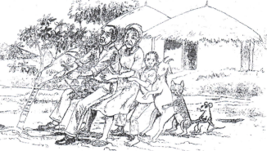Use the picture and read the passage to answer the questions that follow.**

**The farmer and the cassava**

A farmer planted a little cassava. It grew into a very big cassava. One day, the farmer went to pull it up. He could not pull it up because the soil was very dry. He called his wife. His wife pulled him and the farmer pulled the cassava. They pulled and pulled, but could not pull it out.

His wife called her daughter. The girl pulled her mother. Her mother pulled her husband. The farmer pulled the cassava. They pulled, but could not pull it up.

The girl called a goat. The goat pulled the girl.

The girl pulled her mother. Her mother pulled her husband. The farmer pulled the cassava. They pulled, but could not pull it up.

The goat called the cat. The cat pulled the goat. The goat pulled the girl. The girl pulled her mother.

Her mother pulled her husband. The farmer pulled the cassava. They pulled, but they could not pull it up. They poured water on the dry ground around the cassava to make it wet and soft.

Then the cat called the mouse. The mouse pulled girl. The girl pulled her mother. Her mother pulled her the cassava. Pwaah! Out came the giant cassava.

That night they ate cassava and rabbit meat.

**Questions**

1. Who planted the cassava?

2. Why did the farmer call his wife?

3. Who pulled the farmer?

4. Who did the goat call?

5. How many people and animals pulled up the cassava?

**Team activity**

**Talk about these families.**

|  |  |
| --- | --- |
| **C:\Users\LG COMPUTERS\Desktop\New folder (3)\Reading workbook\happy family.jpg1** | **2** |
| **C:\Users\LG COMPUTERS\Desktop\New folder (3)\Reading workbook\reading family.png3** | **ANd9GcQmdIvgvQuahi84iB9b0Eh2vIXc1aOlz5bRpugAL3lOj4oXnVwY4** |

Corrections

***Score strip***

Name: \_\_\_\_\_\_\_\_\_\_\_\_\_\_\_\_\_\_\_\_\_\_\_\_\_\_\_\_\_\_\_\_\_\_\_\_\_\_\_\_\_

Date: \_\_\_\_\_\_\_\_\_\_\_\_\_\_\_\_\_\_\_\_\_\_\_\_\_\_\_\_\_\_\_\_\_\_\_\_\_\_\_\_\_\_

Spellings Corrections

1. 1.

2. 2.

3. 3.

4. 4.

5. 5.

**Unscrambled Words**

og os

own owgr

nsow wols

Put each set of letters in order to make

a word with the o sound as in low.

Then write the words.

Write two sentences with the words you made.

Corrections

***Score strip***

**Word Order in Sentences**

Words in a sentence

must be in an order

that makes sense.

Read each group of words. Put them

in the order that makes sense.

Then write each sentence.

1. walk We the to lake.

2. frog. a I see

3. eats The frog bugs.

4. a off rock. He jumps

5. moves. The water

Corrections

***Score strip***

****

Checkup 3

Supervisor’s initial \_\_\_\_\_\_\_\_\_\_\_\_

Score \_\_\_\_\_\_\_\_\_\_\_\_\_\_\_\_\_\_

Supervisor’s comment \_\_\_\_\_\_\_\_\_\_\_\_\_\_\_\_\_\_\_\_\_\_\_\_\_\_

**PROJECT WORK**

At home, identify the activities done as a family. Note them down and when you arrive at school the following day, write the activities in a scrap book and draw them.

|  |  |  |  |  |
| --- | --- | --- | --- | --- |
| **WEEK** | **VALUE PROMISE** | **MEMORY VERSE** | **CHARACTER TRAITS** | **WORK HABIT** |
| **FIVE** | “I will always do good to others the way I want them to do for me”. | Proverbs 31: 25 | 1. Be strong and of great dignity  2. Do not be fearful  3. Always work without ceasing  4. Rejoice in the lord and be thankful.  5. Be helpful | Believe you can and you’re halfway there |

Proverbs 31: 25 “She is strong and of dignity; she is not afraid of the future”.

Work habit

Name: \_\_\_\_\_\_\_\_\_\_\_\_\_\_\_\_\_\_\_\_\_\_\_\_\_\_\_\_\_\_\_\_\_\_\_\_\_\_\_\_\_

Date: \_\_\_\_\_\_\_\_\_\_\_\_\_\_\_\_\_\_\_\_\_\_\_\_\_\_\_\_\_\_\_\_\_\_\_\_\_\_\_\_\_\_

School: \_\_\_\_\_\_\_\_\_\_\_\_\_\_\_\_\_\_\_\_\_\_\_\_\_\_\_\_\_\_\_\_\_\_\_\_\_\_\_\_\_

Spellings Corrections

1. 1.

2. 2.

3. 3.

4. 4.

5. 5.

Circle the word for each picture. cake

|  |  |  |
| --- | --- | --- |
| 1.  rake rack | 2.  Image result for snake images clip art black and white  sneak snake | 3.  from frame |
| 4T9zb75rc4.  face fans | sentiment-clipart-leprechaunhatbnw5.  cape cap | 6.    plane plan |
| lake.png7.  lock lake | 8.  tape.png  tape tap | wave.png9.  wave wove |
| skate.png10.  scarf skate | C:\Users\user\Desktop\plate.png11.  plate plum | 12.  shapes shops |
| 13.  get gate | game.png14.  game gum | space.png15.  spice space |

Help Kate get to the lake.

Color each box that has the **long a** sound in **lake.**

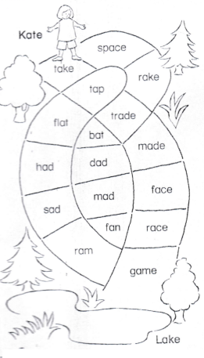Write each long a word you color on the line.

Corrections

***Score strip***

**Read the story and answer the questions.**

**Nate**

We have a friend….

He likes to bake….

His name is Nate….

He made a cake….

Nate gave us cake…..

On a cake plate…..

It was so good…..

We ate and ate….

Then we cleaned up….

We washed our plates…..

We walked right: out…..

The big red gate…..

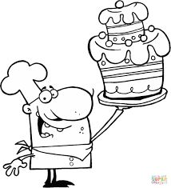

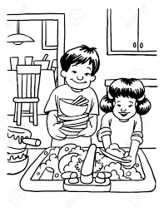

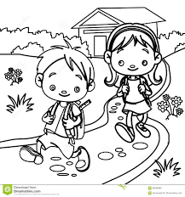

a) What is the title of the story?

b) Write down four words in the story with sound a-e.

c) Take rhymes with

d) They washed the

Corrections

***Score strip***



Checkup 4

Supervisor’s initial \_\_\_\_\_\_\_\_\_\_\_\_

Score \_\_\_\_\_\_\_\_\_\_\_\_\_\_\_

Supervisor’s comment \_\_\_\_\_\_\_\_\_\_\_\_\_\_\_\_\_\_\_\_\_\_\_\_

|  |  |  |  |  |
| --- | --- | --- | --- | --- |
| **WEEK** | **VALUE PROMISE** | **MEMORY VERSE** | **CHARACTER TRAITS** | **WORK HABIT** |
| **SEVEN** | “I choose to be at peace and have good team work”. | Psalm 127:3-5 | 1. Be responsible  2. Be God fearing  3. Be compassionate to your children  4. Be obedient & respect for children  5. Cherish the glory of your children | Discipline is the bridge between goals and accomplishment |

Psalm 127:3-5 “Children are a gift from the lord, they are a real blessing like arrows in the hands of a warrior, are children born in one’s youth”.

Work habit

Name: \_\_\_\_\_\_\_\_\_\_\_\_\_\_\_\_\_\_\_\_\_\_\_\_\_\_\_\_\_\_\_\_\_\_\_\_\_\_\_\_\_

Date: \_\_\_\_\_\_\_\_\_\_\_\_\_\_\_\_\_\_\_\_\_\_\_\_\_\_\_\_\_\_\_\_\_\_\_\_\_\_\_\_\_\_

School: \_\_\_\_\_\_\_\_\_\_\_\_\_\_\_\_\_\_\_\_\_\_\_\_\_\_\_\_\_\_\_\_\_\_\_\_\_\_\_\_\_

Spellings Corrections

1. 1.

2. 2.

3. 3.

4. 4.

5. 5.

My first visit in the airport was an exciting experience.

I had never seen so many airplanes before and I was fascinated by them. I loved watching the planes take off and, even got to go on a plane myself! It was amazing to see all of the airport. I even saw a few celebrities! The people were all so friendly and helpful, and they made sure that I had a great experience.

**Questions**

1. Where did you go?

2. What was your reaction upon first visiting the airport?

3. Did you enjoy watching the airplanes take off?

4. What was it like to go on a plane yourself?

5. Did you see any celebrities while at the airport?

6. What were the people like that you encountered while there?

Read aloud.

**Sound “oa” (o)**

boat coat goat road roar broad

toad load loan goal board float

loaf coal boast shoal foal roam

roast toast soak throat

**Name the pictures.**

|  |  |
| --- | --- |
| https://encrypted-tbn1.gstatic.com/images?q=tbn:ANd9GcTAHay_L0fylxLB0LosMtZC_eUqDEkOJ9WbPq6fwVi1YBwzxZ1M | [https://encrypted-tbn1.gstatic.com/images?q=tbn:ANd9GcQjbQa0x5zl_kMJBigtjWylS-oc2q9E5JElCXk7R6d4nZ1vf6-BEw](http://www.google.com/imgres?imgurl=http://www.frackville.org/wp-content/uploads/2013/12/boat-coloring-pages.gif&imgrefurl=http://www.frackville.org/boat-coloring-pages/&h=637&w=611&tbnid=NmNFN1ezFH4xmM:&zoom=1&docid=HTtJbApqTdIS7M&ei=uTCkU7mkLIKCzAP01oCQCw&tbm=isch&ved=0CF8QMyhXMFc4yAE&iact=rc&uact=3&dur=160&page=15&start=280&ndsp=23) |
| C:\Users\DELL\Desktop\pins 3\Pins\6b4c9b9af74fab6162692122d9bb1e32.jpg |  |

**Fill the gaps correctly.**

**(float, goat, shoal, loaf, roar)**

1. Dad bought a of bread.

2. A piece of a paper can on water.

3. The fisherman had a of fish.

4. Our has two kids.

5. A is like a frog.

6. We heard a of a lion in the forest.

Corrections

***Score strip***

Reading theatre Key

|  |  |  |  |
| --- | --- | --- | --- |
| Value | Fair | Good | Excellent |
| Intonation |  |  |  |
| Expression |  |  |  |
| Punctuation |  |  |  |
| Confidence |  |  |  |

***Score strip***

Name: \_\_\_\_\_\_\_\_\_\_\_\_\_\_\_\_\_\_\_\_\_\_\_\_\_\_\_\_\_\_\_\_\_\_\_\_\_\_\_\_\_

Date: \_\_\_\_\_\_\_\_\_\_\_\_\_\_\_\_\_\_\_\_\_\_\_\_\_\_\_\_\_\_\_\_\_\_\_\_\_\_\_\_\_\_

Spellings Corrections

1. 1.

2. 2.

3. 3.

4. 4.

5. 5.

**BL00130_Sound ou/ow.**

Circle the word for each picture. house

|  |  |  |  |
| --- | --- | --- | --- |
| 1.  floor flower | 2.  couch crush | ANd9GcRV7NzbxBlAzWlz-0JhVwebEX1lgdsjJXEk9t8Jk8AiNceO0Y2B3.  month mouth | C:\Users\user\Desktop\New folder\scan0004.jpg4.  tile towel |
| 5.  D:\MY PHOTOZ\Luganda-BK1\Rat.jpg  mouse mess | C:\Users\user\Desktop\top.jpg6.  chew cow | C:\Users\LG COMPUTERS\Desktop\New folder (3)\clown 1.jpg7.  clown clean | C:\Users\LG COMPUTERS\Downloads\OWL.png8.    owl oil |

Find the word that has the same vowel sound as

Mark the to show your answer.

9. need 10. been

hide brown

found brain

Corrections

***Score strip***

Pick a word from the box to match each picture.

C:\Users\LG COMPUTERS\Downloads\CROWN.pngWrite it on the line. crown

|  |  |
| --- | --- |
| Awesome-Drawing-of-Cow-Coloring-Page1. | BD07837_2. |
| Image result for shop building3. | C:\Users\LG COMPUTERS\Downloads\clown.png4. |
| C:\Users\LG COMPUTERS\Downloads\towel.png5. | C:\Users\LG COMPUTERS\Downloads\owl 2.png6. |

Corrections

***Score strip***

Write the words from the box that rhyme with cow.

1. 2.

Write the words from the box that rhyme with crown.

3. 4.

5. 6.

**Pick a word from the box to match each clue.**

Write it on the line.

7. not up 8. It’s smaller than a city.

**Pick a word from the box to finish each sentence.**

**Pull goes**

Write it on the line.

9. You must the rope down.

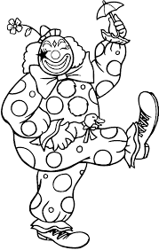10. Now the curtain up.

**Clowning Around**

Read each sentence. Choose the word

that makes sense and write it on the line.

We saw a with big shoes.

**clown town**

He looked at his shoes.

**how down**

He began to yell and .

**shout crowd**

His big toe stuck !

**round out**

Is that something to school ?

**about cloud**

Corrections

***Score strip***



Checkup 5

Supervisor’s initial \_\_\_\_\_\_\_\_\_\_\_\_

Score \_\_\_\_\_\_\_\_\_\_\_\_\_\_\_

Supervisor’s comment \_\_\_\_\_\_\_\_\_\_\_\_\_\_\_\_\_\_\_\_\_\_\_\_

**PROJECT WORK**

1 a) Using newspapers, search for three words of sound “oa” and cut them out. Get your scrap book and paste them in.

b) Construct two sentences about each of the words you found and draw for the words.

**2. Recite the tongue twister**: If a big old toad jumps on the boat as we row across the moat, the boat won’t float.

|  |  |  |  |  |
| --- | --- | --- | --- | --- |
| **WEEK** | **VALUE PROMISE** | **MEMORY VERSE** | **CHARACTER TRAITS** | **WORK HABIT** |
| **EIGHT** | “I believe God will always help me to be a good leader”. | Mathew 20 : 27 -28 | 1. Be a good leader  2. Do not be judgmental  3. Be kind and patient  4. Seeks God’s approval always  5. Be responsible | Discipline is what you must have to resist the lies of excuses |

Mathew 20 : 27 -28 “And whoever would be first among you must be your slave, even as the son of man came not to be served but to serve and to give life as a ransom for many”.

Work habit

Name: \_\_\_\_\_\_\_\_\_\_\_\_\_\_\_\_\_\_\_\_\_\_\_\_\_\_\_\_\_\_\_\_\_\_\_\_\_\_\_\_\_

Date: \_\_\_\_\_\_\_\_\_\_\_\_\_\_\_\_\_\_\_\_\_\_\_\_\_\_\_\_\_\_\_\_\_\_\_\_\_\_\_\_\_\_

School: \_\_\_\_\_\_\_\_\_\_\_\_\_\_\_\_\_\_\_\_\_\_\_\_\_\_\_\_\_\_\_\_\_\_\_\_\_\_\_\_\_

Spellings Corrections

1. 1.

2. 2.

3. 3.

4. 4.

5. 5.

An airport is a location where aircraft, such as airplanes and helicopters, can take off and land. Airports are usually built near cities so that people can travel to and from the city or country easily. The purpose of an airport is to provide a safe place for aircraft to take off and land. Most airports have a control tower, where air traffic controllers direct the movement of air craft. The controllers make sure that the aircraft stay a safe distance a part from each other to a void collision. Some airports have a runway that is long enough to handle the largest commercial airplanes.

Question

1. What is an airport?

2. What is the purpose of an airport?

3. How do air traffic controllers direct the movement of aircraft?

4. Why is it important to have a long runway at an airport?

5. Mention the main airport in Uganda.

**Riddles**

**Complete correctly.**

1. I give you light at night. I am a

.

2. Wild animals are kept in a z .

3. A g looks like a duck.

4. Pupils go to s to learn.

5. They go with b , pens and pencils.

6. We can get blankets, sweaters, jackets, from w

7. Our house has a green r .

8. We say one but many teeth.

Corrections

***Score strip***

 Checkup 6

Supervisor’s initial \_\_\_\_\_\_\_\_\_\_\_\_

Score \_\_\_\_\_\_\_\_\_\_\_\_\_\_\_

Supervisor’s comment \_\_\_\_\_\_\_\_\_\_\_\_\_\_\_\_\_\_\_\_\_\_\_\_

|  |  |  |  |  |
| --- | --- | --- | --- | --- |
| **WEEK** | **VALUE PROMISE** | **MEMORY VERSE** | **CHARACTER TRAITS** | **WORK HABIT** |
| **NINE** | “I believe God will always help me to be devoted”. | John 3 : 16 | 1. Be so loving  2. Be prayerful and alert  3. Fear God as your teacher  4. Honor one another  5. Be faithful. | Excellence is not a skill. It’s an attitude |

John 3:16 “For God so loved the world that he gave his only begotten son, that whoever believes in him shall not perish but have eternal life”.

Work habit

Name: \_\_\_\_\_\_\_\_\_\_\_\_\_\_\_\_\_\_\_\_\_\_\_\_\_\_\_\_\_\_\_\_\_\_\_\_\_\_\_\_\_

Date: \_\_\_\_\_\_\_\_\_\_\_\_\_\_\_\_\_\_\_\_\_\_\_\_\_\_\_\_\_\_\_\_\_\_\_\_\_\_\_\_\_\_

Spellings Corrections

1. 1.

2. 2.

3. 3.

4. 4.

5. 5.

**Sound sw**

**Read aloud.**

aweet swing swim

aweep swell

**Read and draw.**

Jane is swimming.

Tom has ten sweets.

The swing is green.

***Score strip***

Name: \_\_\_\_\_\_\_\_\_\_\_\_\_\_\_\_\_\_\_\_\_\_\_\_\_\_\_\_\_\_\_\_\_\_\_\_\_\_\_\_\_

Date: \_\_\_\_\_\_\_\_\_\_\_\_\_\_\_\_\_\_\_\_\_\_\_\_\_\_\_\_\_\_\_\_\_\_\_\_\_\_\_\_\_\_

Pick a word from the box to match each clue.

Write the words in the puzzles.

hear jump more sleep time with

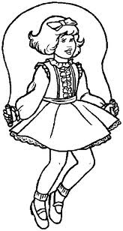**1.**

1.

2.

3.

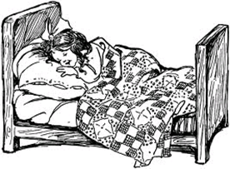2. The pup wants one hug.

3.

4. Can I go you?

4.

5.

6.

5. It is of bed.

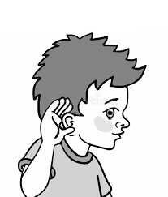

6.

Corrections

***Score strip***

Name: \_\_\_\_\_\_\_\_\_\_\_\_\_\_\_\_\_\_\_\_\_\_\_\_\_\_\_\_\_\_\_\_\_\_\_\_\_\_\_\_\_

Date: \_\_\_\_\_\_\_\_\_\_\_\_\_\_\_\_\_\_\_\_\_\_\_\_\_\_\_\_\_\_\_\_\_\_\_\_\_\_\_\_\_\_

Spellings Corrections

1. 1.

2. 2.

3. 3.

4. 4.

5. 5.

**Read aloud.**

|  |  |  |
| --- | --- | --- |
| **pail** | **pray** | **nails** |
| **way** | **pay** | **paid** |
| **gain** | **tray** | **afraid** |
| **may** | **maid** | **mail** |
| **main** | **day** | **hair** |
| **say** | **chain** | **chair** |

**How many words can we make?**

|  |  |  |
| --- | --- | --- |
| aw | s | ail |
| gr | ay | j |
| p | h | ow |

Corrections

***Score strip***

**Name That Picture**

pail pay

snail hay

train chain

Read each word in the box. Write each

picture name on the line.

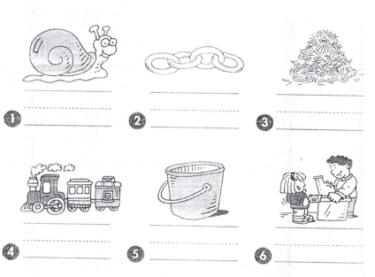

Write a sentence using each word given.

**Play**

**Today**

Corrections

**Could it be true?**

Read each sentence. If it is true, write yes on the line. If it is not true, write no on the line.

**A snail has a shell.** Yes

**A boy can sail in a gray plane.**

**We may get mails today.**

**We play inside when it rains.**

**We wait for a train in a cave.**

**The grain paid to stay in the pail.**

Corrections

***Score strip***



Checkup 7

Supervisor’s initial \_\_\_\_\_\_\_\_\_\_\_\_\_

Score \_\_\_\_\_\_\_\_\_\_\_\_\_\_\_\_

Supervisor’s comment \_\_\_\_\_\_\_\_\_\_\_\_\_\_\_\_\_\_\_\_\_\_\_\_